


‘Adding Value to the Occupational Therapy Care Pathway for Children with Developmental Coordination Disorder (DCD)’.

The AHP Service Improvement Project has enabled Calderdale and Huddersfield NHS Foundation Trust Children’s Occupational Therapy service to………

Deliver improved access and service experience for children with Developmental Coordination Disorders and their carers by re-designing the care pathway to create a more efficient and effective service:-
- Waiting times reduced from 20 weeks to a range of 1 to 11 weeks for the 24 children referred since 01/10/10. Emerging trend = 6 weeks as the average wait
- 96% of parents accessing the service in the first three months of implementation report acceptable waiting times
- 98% of parents and children report being very satisfied or satisfied with the service

Improve the quality of patient care by involving children and parents in decisions about their treatment. By working in partnership with the therapist to set a therapy goal, the child’s intervention is specific, resulting in increased motivation and long term responsibility for self management:-
- 98% of patients now following re-designed care pathway and inputting into their care management/options for intervention
- 90% of children have set jointly agreed goals with the therapist

Increase productivity and improve the clinical outcomes for children. The service has moved from offering assessment/advice only to delivering an individualised package of care including advice, individual or group therapy as appropriate:-
- Number of children previously receiving individual or group intervention = 0. Number of children who have now received individual or group intervention = 24
- 70% of parents who completed an outcome questionnaire reported the intervention had made a difference to their child

Our Service Profile
The aim and objective of the OT service is to help children with Developmental Coordination Disorder (DCD) to do the things other children take for granted, providing support and strategies to develop skills such as handwriting and hand strength, dressing and fastenings, riding a bike, catching a ball, using cutlery, and planning and coordinating activities, enables children to have a better chance of accessing education and achieving their potential. We aim to reduce the long term impact of DCD on the child's self esteem and difficulty making social relationships because of their difficulties, and therefore address their feelings of isolation and distress. By encouraging children and parents to be involved in decisions about their care, we facilitate their ability to self manage the difficulties long term.

The Children’s Occupational Therapy service sits within a Children’s Therapy Team, providing input to children aged 0 – 19 years who require Occupational Therapy, and/or Speech and Language Therapy, and/or Physiotherapy. Developmental Coordination Disorder (DCD) is a life long disability, often occurring in isolation and not related to any physical or cognitive impairment. On average 10 children are referred every month to the service either from parents or various professionals, though the majority are received from Education.

Our difficulties prior to the SIP

Access: - Prior to redesigning the care pathway, the time from referral to the end of assessment for children to this service was up to 20 weeks. This was unacceptable for the children and their families, often leading to more severe problems in both the condition and the impact of the difficulty.
Quality & Productivity: - The assessment session was taking a considerable length of time because of the standardised, in depth assessment and report provided for all new referrals. As a consequence, we were unable to provide any clinical time for follow up intervention for the children following the assessment, and the only treatment offered to children and their families was verbal advice and the written report. The children were discharged following the assessment/advice; therefore the unmet need of follow up intervention was hidden and outcomes were less effective.

Variability and different service models: - The service is delivered in two different sites, and prior to the service improvement, there was variation in the waiting times and productivity depending on the grade and clinical expertise of the therapist and the use of rotational staff. There was also no clear pathway or consistent sharing of information across the two localities.

Dissatisfaction from staff: - Therapists expressed concern about the long waiting times, clinical outcomes and effectiveness of the service delivery for this client group compared to other service users accessing OT.
What we did

- Consulted stakeholders including commissioners, previous service users and therapists, and incorporated their views regarding their experience and outcomes of the service in order to shape our improvements
- Engaged staff in the process of re-design and used their support of each other to overcome the challenges of cross site working
- Redesigned the care pathway to deliver a consistent efficient service including options for therapy intervention and discharging patients
- Devised an initial consultation process to allow time for a more stream-lined assessment and identification of a patient-led goal; and created a report template to be completed at the initial consultation thus reducing the need for additional therapy admin time
- Re-organised the skill mix to increase effectiveness of senior therapists within the team – initial assessment consultation sessions now delivered by experienced therapists and intervention sessions led by lower grade clinicians
- Sourced child -friendly materials to aid joint goal setting
- Carried out a waiting list initiative during school holidays to get rid of the backlog of referrals
- Re –arranged diaries to set up regular assessment and therapy intervention sessions
- Developed an experience and outcome questionnaire to implement with children and carers in order to continuously re-design and improve the service as appropriate

Our Results

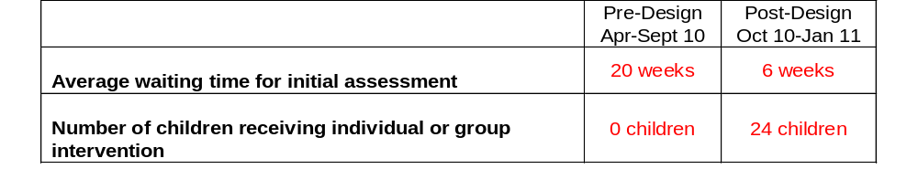41 responses Child Experience Questionnaire Oct 2010 – Jan 2011

“What did you think about your visit to see the occupational Therapist?”


Fun OK Didn’t Enjoy
33
7
1

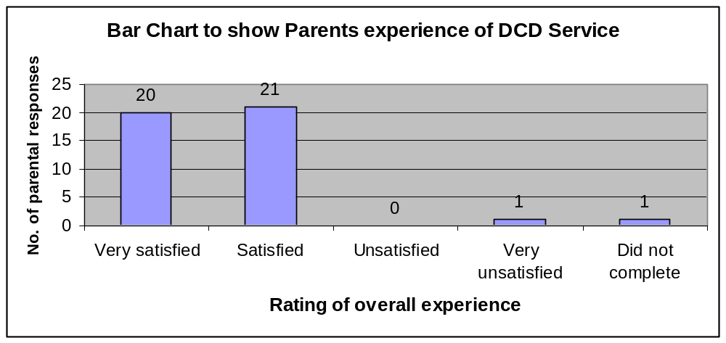

What parents said about the new service..................
- “He’s got more confidence and willing to try new things”.
- “He’s not falling over as much when trying to balance. School know now what activities to do which will benefit him.”
- “Finds P.E easier”. “Better at dressing himself”.
- “Handwriting is much clearer and he doesn’t get as frustrated and doesn’t feel under quite as much pressure”.
- “More confident with running and jumping”.

A Child’s Story.........................
Child S was referred to Children’s OT by his parent at 8 ½ years of age. Assessment indicated he was experiencing difficulties with eye-hand coordination, spatial awareness, visual motor speed, manual dexterity, figure/ground discrimination and balance. These problems affected Child S in many ways, both at home and at school, resulting in him falling behind with his school work.

Child S struggles to sequence tasks correctly and requires regular prompting to avoid becoming muddled and confused when completing tasks. This has a negative effect on his self esteem with feelings of frustration and hopelessness when he compares himself to his peers.

Child S struggles with maintaining his balance which affects his posture and increases his fatigue, contributing to difficulties maintaining concentration and his ability to learn. Activities of daily living all require substantial balancing skills, and this difficulty means that every day the ‘boring’ tasks take up proportionally more of his time than normal, leaving less time for the ‘fun’ things.

Child S struggles to discriminate shapes and patterns because of difficulties with normal figure/ground skills. This skill is important in recognising and discriminating shapes and patterns and will impact on his ability to read and do maths. At home, familiar socks and underwear mixed up in a drawer are difficult for him to recognise.

Child S finds it difficult to judge the speed of oncoming objects and to evaluate the distance between himself and stationary things. This makes participation in games and sports particularly challenging for him and potentially socially excluding.

As a result of attending the re-designed OT service, Child S was assessed within 6 weeks of referral and booked into a programme of therapy sessions immediately post assessment. It was initially difficult to set a therapy goal because of the complexity of his needs; however the goals appeared naturally once the intervention sessions began. The goals were specific and attainable, and Child S became even more motivated to attain the goals because he ‘owned them’.

Therapy intervention has had a positive impact on Child S’s achievements both at home and school, and he reports feeling happier because he doesn’t appear so different. Child S’s parent reports that his concentration has improved and he is now steadier on his feet. She concludes “S is now more enthusiastic and confident in everyday life”.
The changes we have made will bring benefits to..............

Children – faster access means early intervention and help at the right time - instant feedback, opportunity to try out equipment, information and strategies to take away improving their quality of life

Staff – “a service to be proud of” with an effective and efficient service delivered across both sites, resulting in improved sharing of information and support amongst therapists

Commissioners – early productivity improvements, for example, trialling equipment at the initial consultation session reduces the need for follow up appointments and increase in contacts through the introduction of individual or group intervention sessions without increase in staff members, but achieved through shifting of resources from other parts of the OT service; service users engaging in their treatment and self management potentially leading to reduced need for long term dependency on therapy resources.

What we need to continue.……

In achieving the benefits outlined above, we have identified a number of issues or challenges to address through the next phase of improvement:-

- Achieving an increase in contacts has placed increased pressure on other parts of the OT service. Although this has created a more equitable use of resources, it has also highlighted a need to scrutinise other children’s services in terms of consistency of access criteria, capacity and demand and through- put; and to implement service improvement initiatives in these teams

- Engaging and encouraging service users in identifying their treatment goals has proved more difficult than expected. We need to implement training for therapists to help them communicate and facilitate setting treatment goals and discussions regarding long term self management with children and carers; and to consistently measure their clinical effectiveness through patient reported outcomes

- A secondary benefit of the SIP was achieved through the commissioning of additional therapy time from a member of staff to devise and produce an information and training booklet for practitioners and educators. The next step is to extend our pathway by developing partnerships with the children’s workforce in order to share and utilise these training materials. Firstly, we need to explore the opportunities to deliver training packages so that health and education can work together on the prevention of developmental motor difficulties; and secondly, to enable collaboration between the key agencies to support children and young people with identified coordination difficulties to ensure these young people achieve maximum outcomes within their educational and community settings.

Our top tips for services improvements..............

- Don’t underestimate the time and commitment needed from the team to plan and implement service changes
- You need everyone on board in order for changes to happen – use peers to encourage and influence each other – the positive is improved cross site working
- Assign roles and responsibilities to staff - good planning and monitoring with accountability is vital
- Set ‘SMART’ outcome measures and ensure you have reliable data to measure service baselines and outcomes
- Ensure everything is in place prior to implementing the service re-design to feel the maximum benefit from the improvement and maintain momentum within the team.

