Developing a Preventative Pathway for School-Aged Children with Speech, Language and Communication Needs
Janet Harrison, Deanne Rennie, Colin Purves, John Barnett, Anne Wright, Elaine O’Connor, Jenny Dundas
Project Sponsor: Anne Maria Olphert

Box 1: Big Picture Success Story

The Service Improvement Project (SIP) has improved access to speech and language therapy for school aged children with speech, language and communication needs (SLCN) across Leicester, Leicestershire and Rutland. This has been achieved by redesigning existing pathways and developing a new pathway for school aged children with SLCN. The SIP work focused on more effective management of demand and increasing available capacity to enable more timely access to the service. The referral to treatment time has reduced from an average of 10 to 5 weeks. In January 2011 no child had to wait over 18 weeks in any part of the service as compared to 190 children at the start of the project. Effective use of data and information has supported service redesign and enabled capture of productivity and cost efficiency gains. In addition to RTT improvements a cost efficiency gain of £29,000 per annum has been predicted

Box 2: Service Context (background to improvement activities)

The Children’s Speech and Language Therapy Service meets the needs of children with speech, language and communication difficulties and provides specialist support for children with eating, drinking and swallowing difficulties. The service is a provider organisation that sits within Leicester City Community Health Service. The team work across two Primary Care Trusts and three Local Authorities providing for children aged 0-19 years in Leicester, Leicestershire and Rutland. The population size of children aged 0-19 years is estimated to be 238,896 and the number of different languages used is at least 95. The service receives, on average, 57 referrals per week

Box 3: Strategic priorities to be addressed by the SIP

Quality
- Prevent inappropriate referral of school aged children to the service where needs can met within the school environment
Inappropriate referrals to speech and language therapy contributed to the large caseload sizes for clinicians. In April 2010 the caseload size for the clinicians locally was above the national average in speech and language therapy (RCSLT Q-SET 2010)
- Align clinical information with administrative components to bring about improvement across a pathway

Productivity
- Improve data capture to underpin service planning and redesign
A lack of robust systems for capturing, managing and reporting on data impacted the ability to plan and measure service improvement. A mixture of manually captured data, and limited electronically captured information was in place at the start of the project
- Streamline administrative steps in existing pathways
Streamlining processes and eliminating points of waste aimed to improve quality and productivity through reductions in time and costs
- Ensure resource allocation directed to meet specialist needs
This would enable the redirection of resources to those children with specific needs for specialist support. Precise data on the number of children was not available at this time due to restricted systems in data capture
- Embed the QUIPP agenda within service plans for 10/11
Successful delivery of the QUIPP agenda depended on all the team having ownership of the work. Delivering on the RTT targets required an increased awareness of productivity across the service of RTT requirements and priorities

Access
- Be compliant with both national and local RTT targets
In April 2010 data illustrated an average waiting time of 10 weeks with 140 children waiting over 18 weeks. The service at this stage was not compliant
- Effectively disseminate the new school age referral guidelines

Outcomes
- Reflect the evidence base to deliver service improvement and change
It was estimated that at the start of the project children were entering onto caseloads who would have better outcomes if managed through a different pathway

Box 4: What they did and what they changed as a result of the SIP

Working with our stakeholders, we have transformed our service by:

- Developing an information system and live online reporting of RTT, activity and referral information
We established the use of SharePoint as a business intelligence platform to enable and the capture of live patient activity data linked to the Electronic Patient Record
- Streamlining the processing and administration of new referrals through removing unnecessary stages
Combining two processes within the referral system reduced the RTT by a minimum of two weeks. Extending the initial appointment time for clinicians by 15 minutes enables two appointment slots to be merged to one thus reducing the number of follow up sessions required having direct cost benefits
- Developing a new clinical pathway with clear entry criteria for school aged children
- Improving the scheduling and allocation of first appointment slots
- Delivering training to key stakeholders on the use of the referral guidelines and strategies to support self-managed care
- Establishing a cross speciality team including clinicians, management, administrators and information analyst to ensure merging of clinical, technical and administrative aspects of the service
The skill mix within the team enabled all aspects patient care to be merged to ensure a seamless, clinically valid, data driven pathway
- Enabling clinicians and information analyst to attend leadership events to enhance their knowledge and skills in service wide issues
- Using SharePoint to enable successful project management within the Plan, Do study and Act framework across the team
The service covers a large geographical area with the team based in their own localities. The use of SharePoint enabled effective communication, project planning, data capture and evaluation and document management
- Investing clinical time to pilot the new pathway, engage in project meetings and deliver training

Box 5: Demonstration of achievements (results/findings)

We have delivered improvements across our service in productivity, outcomes, quality and access. The achievements are outlined as follows:

Quality

Improved SENCO satisfaction - SENCO satisfaction was measured with a pre and post questionnaire. This data is still under collection and not yet available. Anecdotal comments given to the clinicians working on the project are positive. While this data is difficult to capture it may be reflected in a longer term change in referral rates to the service and encouraging schools to support the children’s speech, language and communication needs within their educational context

Productivity

Compliance with RTT targets - the service achieved compliance with the local RTT targets 7 MONTHS earlier than predicted at the start of the project.

TABLE 1: Data capture and reporting post project

Data/Reporting Item | Monthly | Quarterly | Annually
Number of patients attending first appointment? | X | X | X
Average RtT waits for patients attending first appointment? | X | X | X
Maximum RtT wait for patients attending first appointment? | X | X | X
Profile of RtT waits for patients attending first appointment? | X | X | X
Number of patients breaching local-developed RtT standards? | X | X | X
Proportion of patients breaching local-developed RtT standards? | X | X | X
As a direct result of the SIP the average RTT wait reduced from 10 weeks to 5 weeks. The number of children waiting over 18 weeks reduced from approximately 140 before the project started to 0 still outstanding. The data illustrating the reduction in referral to treatment time is shown below

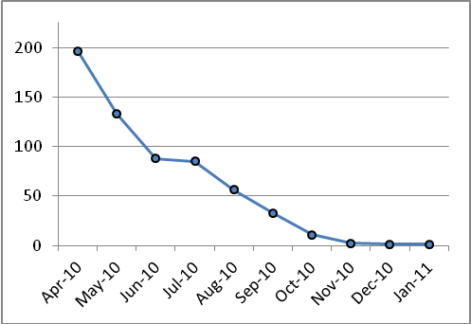 | 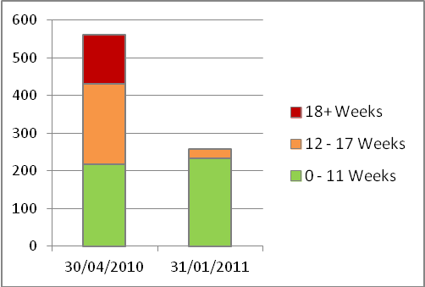
CHART 1: Maximum number of children waiting over 18 weeks in each month, from April 2010 to January 2011 | CHART 2: RTT waiting list profile, end April 2010 compared with end January 2011

Cost benefits realised - the streamlining of processing referrals has led to efficiency gains outlined in Table 2 leading to an annual reduction of waste of £29,846.

TABLE 2: Comparison of costs pre and post pathway

Total Cost of Referrals Processing | Individual Referral | Per Week | Per Annum
Pre Pathway Project | £103.26 | £5,899.37 | £306,767.05
During Pathway Project | £111.26 | £6,356.09 | £330,516.49
Post Pathway Project | £93.22 | £5,325.40 | £276,920.59
Difference Pre & Post SIP Pathways Project  (red = cost saving) | -£10.05 | -£573.97 | -£29,846.47
% | -10% | -10% | -10%

Outcomes

TABLE 3: Illustration of data of Preventative Pathway

Preventative Pathway Stage | Number of Children | Percentage of children on Preventative Pathway
Children on Preventative Pathway | 83 | 100
Taken on to Community Caseload | 28 | 33.7
No SENCO Visit in Time | 1 | 1.2
Awaiting SENCO First Visit | 6 | 7.2
Awaiting Second SENCO Contact | 41 | 49.4
Second SENCO Contact Completed | 7 | 4

Overall 33% of children were taken onto caseload after the second school visit. Thematic analysis of the reasons for this qualitative data indicated the following factors:
- SENCO not feeling able to self-manage the needs of the child
- The need for diagnostic work around complex communication
- Parental anxiety
- Cross over of communication between local therapist and project team

This data is being used to inform the next stages of service improvement

Access

Improved knowledge and use of the referral guidelines - the main sources of referrals for children on the pathway are education staff and paediatricians. This helped us to target training on the referral guidelines
- Training has been delivered to:
- The teachers within the Special Needs Teaching Service (Leicester City) – 15 staff
- Educational Psychology Service – 15 staff
- City and County SENCOS – 34 staff
- Additional training is planned for County SENCO’s, paediatricians and County Educational Psychologists
- Access to referral guidelines has been improved through better web links and improved communication
- School Specific Support – 83 children have entered the pathway and as part of this their individual schools will have received support in implementing and using the guidelines and strategies

Box 6: What have been the benefits?

The changes we have made will bring benefits to our stakeholders by……

- Children and Families - reduced length of wait for children to access the service and new Pathway enables less medical approach to meeting SLCN

- Commissioners - Compliance with RTT targets ensuring quick access for the population they are commissioning for and cost benefits realised to ensure effective allocation of resources to maximise productivity and quality

- Organisation - Development of innovative information capture and analysis system linked to the Electronic Patient Record which can be deployed across the whole organisation impacting on improved productivity and quality across the whole of LCCHS

- Speech and Language Therapy Service - Improved data capture system coupled with new pathway allows better service improvement planning and effective resource allocation

- Education - Improved knowledge of strategies to support children with speech, language and communication needs within their own context and mirroring the Code of Practice

Box 7: What next?

We will continue to improve by:

- Deployment of SharePoint across the LCCHS organisation to improve data driven service redesign. This has attracted additional funding of £40,000 to implement this work
- Embed and extend the use of the preventative pathway service wide to locality teams
- Validate and extend the use of the pathway costing tool to the Community Pathways within speech and language therapy

Box 8: Project Outcomes

Other services can achieve what we have achieved by…….

- Establishing a committed cross-specialty team with a definite goal
- Establishing common language within the team. The use of SharePoint as a project management and collaboration tool has facilitated communication and reduced the need for frequent project meetings
- Ensuring adequate supporting technology is in place
- Clearly identifying what data is needed from the outset
- Recognising that good data which clearly demonstrates productivity and efficiency gains attracts interest and money!
- Clearly identifying and scrutinising current pathways enables the elimination of points of waste in addition to providing a basis for defining costs
- Recognising that there are many resources available to help with service improvement. These may be through Department of Health web based resources or people within and beyond the organisation
- Recognising that things will never always go to plan. Managing risks and potential barriers along the way will ensure the project continues and achieves its goals

